Projekt Plan (ved projektets start)
Programmeringssprog: C#
UI Framework: WinUI 3

Mål: lav et kanban board i stil med billedet herunder + ekstra features, hvis der er tid.
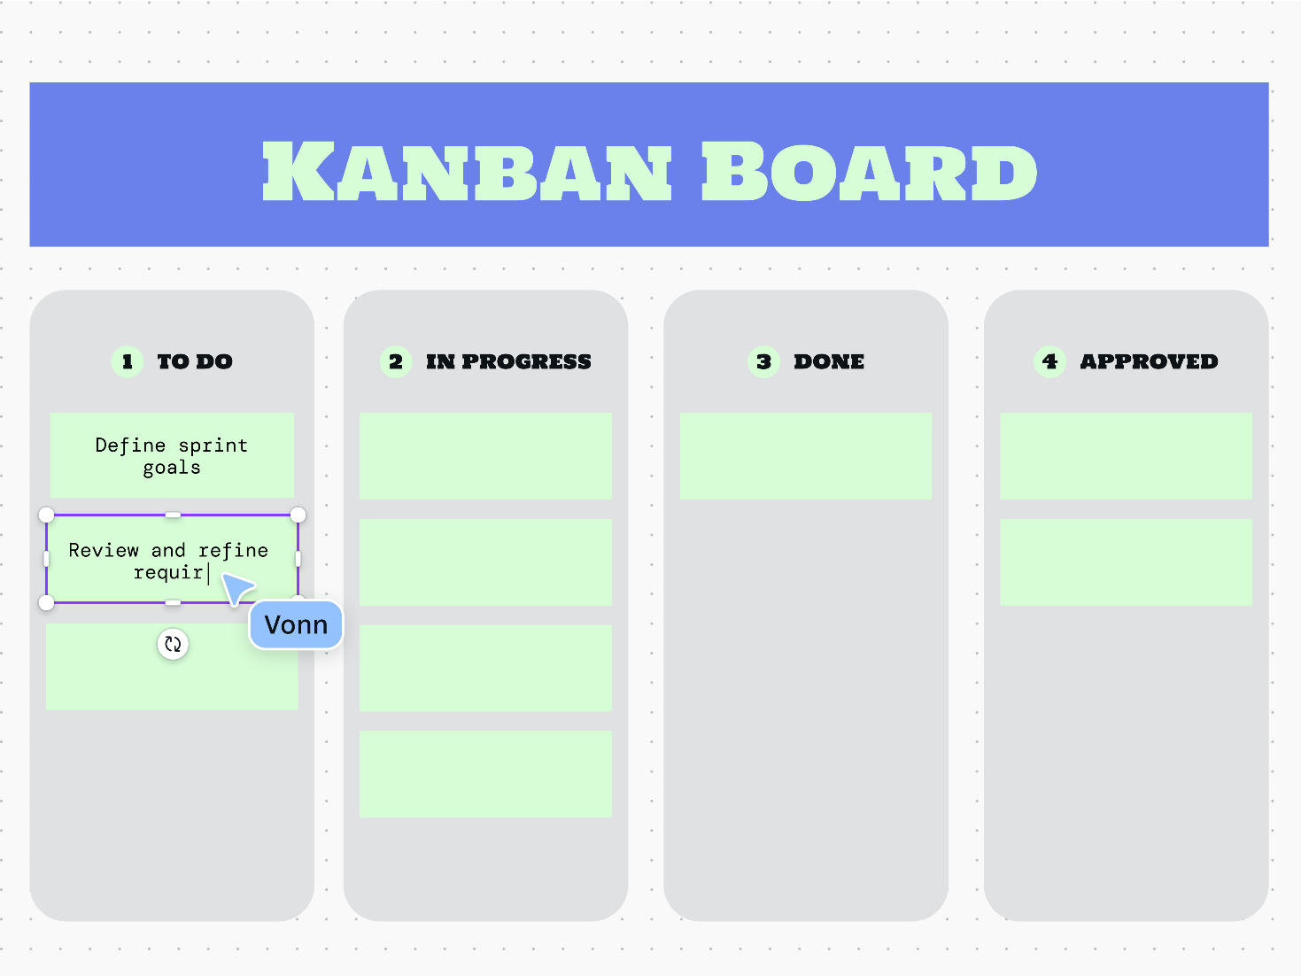
I forhold til opgavebeskrivelsen skal det være muligt at oprette og slette todo’s, visningen af todo’s er ca. som i billedet og status indikeres ud fra hvilken kolonne en todo tilhører. Ændring af todo status gøres via drag & drop til en ny kolonne.
Projekt Plan (Web)
- Omskriv via AI til en web udgave i Blazor
Docker til at bygge og starte app'en
- Ret eventuelle fejl (primært layout, funktionalitet blev generelt bevaret)
Additional Software Architectural Considerations
Save/load board state via json serialize/deserialze
Advantages: it is fast to implement, in comparison to a database, which gave us more time to work on the rest of the app, while generally still operating as a released app would.
Disadvantages: some changes to the ToDoBoard currently requires temporarily bypassing the loading mechanism, which leads to losing all created notes. An example is when ToDoBoard needed a StatusColumn to store deleted notes for the trash bin. Aside from changes to the data structure, changes to it's functions do not have this problem.
Why it works
If we consider this a mock-version of what a released app would need, we consider the advantages in time saved for this component, to be worth not having a complete implementation for this functionality. It may also be possible to move notes from an older version of the class to an updated one, in theory.

Lookup with Guid
Advantages: the UI does not need to know the exact position of a note/column in a list, which simplifies function calls in the UI.
Disadvantages: every lookup can at worst need to check every note we have, to find the specific one needed, which lowers performance. These calls are frequent, so the app's workload grows proportionalyl to the number of notes, for many function calls (and similarly for columns, but they are far less numerous).
Why it works
Our expectation is that it would require several thousand notes, before the apps performance becomes a real problem on modern hardware, which greatly exceeds the number of notes, we would expect users to need. So in this case, we weighted simplified UI function calls over performance.

Drag & drop
Advantages: it makes arranging notes and columns simple for the user, whereas an alternative implementation with buttons would clutter the UI.
Disadvantages: at the start of the project, we thought this might be too ambitious and we were concerned that it might not be realistic to expect a good implementation of this.
Why it works: the original WinUI 3 framework had great support for drag & drop and getting to a working version for notes took much less time than we had thought. Though our current implementation does have a few quirks, such as requiring pointing on a specific note, to be able to place a note at that position (but the space in between notes does not work), so our concerns were not entirely unjustified.

Maintain both a desktop and web version of the app
Advantages: an AI translation from C# + WinUI 3 to a Blazor based web version was able to preserve almost all implemented functionality, mainly requiring layout changes to match our original desktop version.
Preserving an up to date desktop version, thus allows us to do another full AI conversion, should this become necessary.
It also allows us to have a makeshift example of multiple users, when the web and desktop app works on the same board.
It is also a great learning experience, which is also a priority in general for us.
Disadvantages: the requirements for the project changed along the way, requiring only a web version of the app. An up to date desktop version thus requires additional time to maintian, which we weren't specifically asked to spend our time on.
Our controller situation is less simple than it could have been – we originally needed just one controller for the desktop version, but to support both the desktop and web version, our controller needed to be split into multiple parts, to cover all scenarios.
It may also be harder to ask an ai to model the web and and desktop app separately, as it might prefer to model the system as a whole by default.
Why it works: in addition to the advantages, a desktop app without event based communication might try to update the UI before a change has occurred, when the controller and UI is separated by a network connection, so this also helped demonstrate the value of event based communication.

Projekt Forløb
Oversigt over de forskellige udvidelser til app'en. Rækkefølgen er dog lidt sådan ca., da flere dele har fået løbende opdateringer, efter de er blevet nævnt herunder, men det matcher godt med hvor de forskellige dele har fået deres første fungerende udgave af komponenten.
1 | Initial Project Plan  - C#  - WinUI 3  - Make a kanban board with drag&drop
2 | Initial Model  - ToDoNote  - StatusColumn (list of ToDoNote)  - ToDoBoard
4 | Initial Model Tests  - Create/delete column  - Add todo  - Move todo
5 | Store/Load Board  - Save board via Json serialize  - Load board via Json deserialize
6 | Initial controller  - Create todo  - Get column names  - Get todo’s
7 | Initial UI  - 3 column layout (Planned, In Progress, Completed)  - Initial add todo button (1st column only, no editing)
8 | Events  - UI sends events instead of calling controller directly (generally)  - Controller listens for events and reponds
9 | Column Actions  - Create column  - Edit column  - Delete column
10 | File Attachments  - Attach a file to todo  - Remove attached file
11 | Version 1.0  - Supports column actions (create, edit, delete)  - Supports note actions (create, edit, delete)  - Missing drag&drop
12 | Multiple board support via import/export  - Export board to file  - Import board from file
13 | Languages  - Support multiple languages  - Select via drop-down list
14 | Themes  - Select color for buttons  - Select color for some text (shared with buttons, changes column title color)
15 | Drag & Drop  - Drag & drop for notes  - Drag & drop for columns
16 | Testing  - Enforce 95% test coverage on Github  - Test files for each section of the app
17 | Trash Bin  - Deleted notes are moved to the trash bin  - Permanently delete note  - Restore note to active notes
18 | Tags  - Add tag(s) to notes  - Change tag color  - Filter button to show only selected tags
19 | Web app  - Full app AI conversion to Blazor  - Preserves functionality, but layout changes occur  - Build and launch with Docker
20 | Restore UI for Web App  - Similar layout in web version as the original desktop app  - Dialog buttons span width, vertical note buttons, attachments behave as buttons
21 | Feedback on delay  - Drag & drop is darker, while it waits to complete

